QUESTION-1:
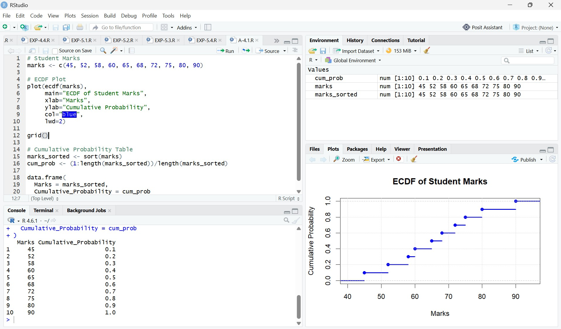

CODE:
# Student Marks
marks <- c(45, 52, 58, 60, 65, 68, 72, 75, 80, 90)

# ECDF Plot plot(ecdf(marks),
main="ECDF of Student Marks", xlab="Marks",
ylab="Cumulative Probability", col="blue",
lwd=2) grid()
# Cumulative Probability Table marks_sorted <- sort(marks)
cum_prob <- (1:length(marks_sorted))/length(marks_sorted)

data.frame(
Marks = marks_sorted, Cumulative_Probability = cum_prob

Interpretation

- The ECDF increases step-by-step as marks increase.
- 50% of students scored 65 marks or less.
- 80% of students scored 75 marks or less.
- All students scored 90 marks or less.

QUESTION-2
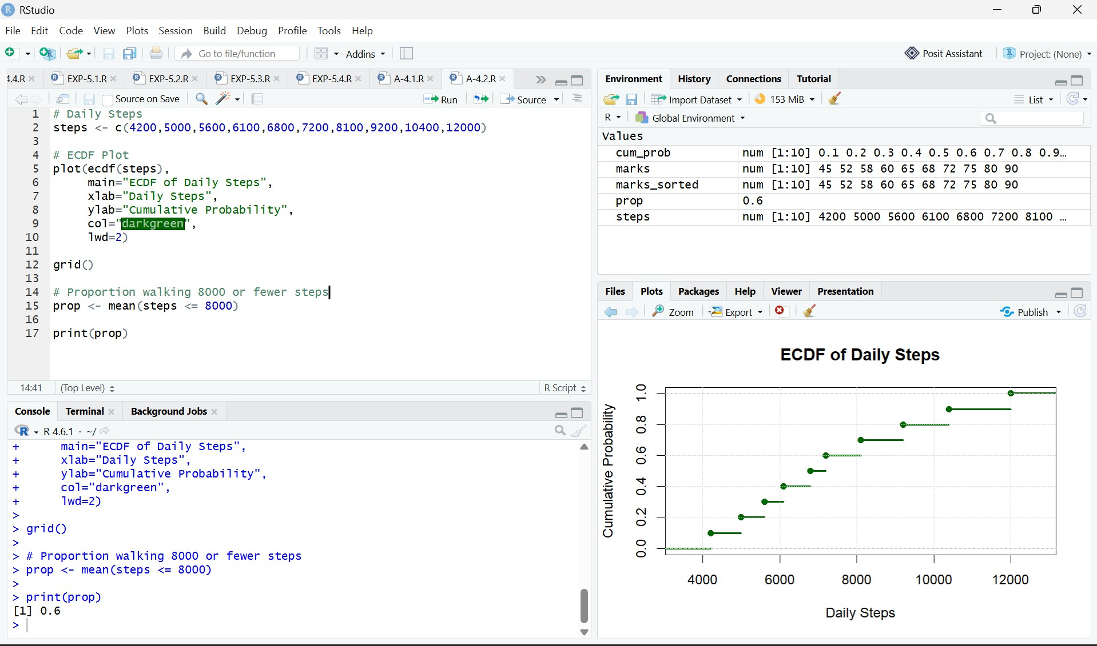

CODE:

# Daily Steps

steps <- c(4200,5000,5600,6100,6800,7200,8100,9200,10400,12000)

# ECDF Plot plot(ecdf(steps),
main="ECDF of Daily Steps", xlab="Daily Steps", ylab="Cumulative Probability",

col="darkgreen", lwd=2)
grid()

# Proportion walking 8000 or fewer steps prop <- mean(steps <= 8000)
print(prop)

Interpretation

- 60% of participants walked 8000 steps or fewer.
- The ECDF helps determine the percentage of observations below any specified value.
- It is useful for comparing distributions and identifying percentiles.

QUESTION-3:
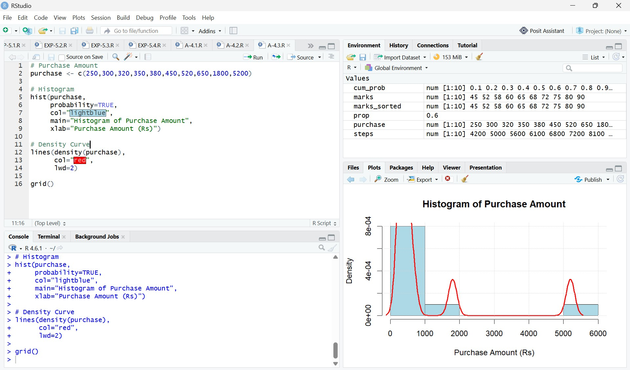

CODE:
# Purchase Amount
purchase <- c(250,300,320,350,380,450,520,650,1800,5200)

# Histogram hist(purchase,
probability=TRUE, col="lightblue",
main="Histogram of Purchase Amount", xlab="Purchase Amount (Rs)")

# Density Curve lines(density(purchase),
col="red", lwd=2)

grid()

Interpretation

The distribution is positively skewed (right-skewed) because:

- Most purchase amounts are between ₹250 and ₹650.
- Two large values (₹1800 and ₹5200) create a long right tail.
- The mean is greater than the median due to these high-value purchases.

QUESTION-4:
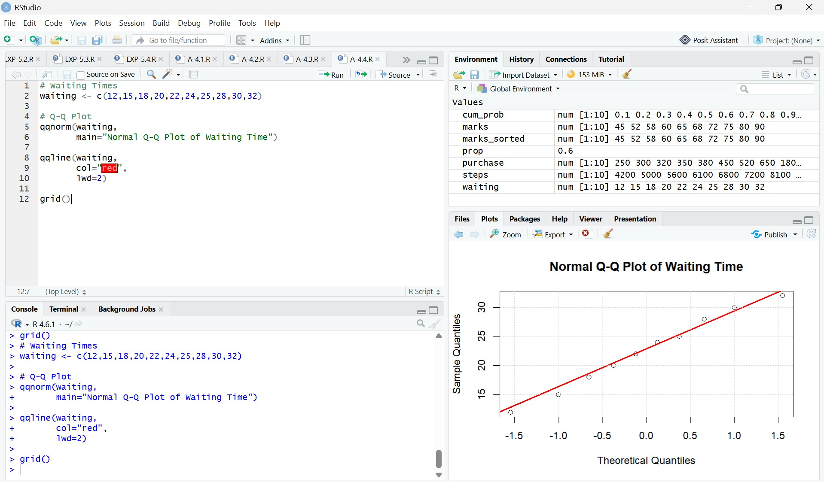

CODE:

# Waiting Times

waiting <- c(12,15,18,20,22,24,25,28,30,32)

# Q-Q Plot qqnorm(waiting,
main="Normal Q-Q Plot of Waiting Time") qqline(waiting,
col="red", lwd=2)
grid()

Interpretation:

- Most points lie close to the reference line.
- There are no major deviations.
- Therefore, the waiting time data is approximately normally distributed.

QUESTION-5:
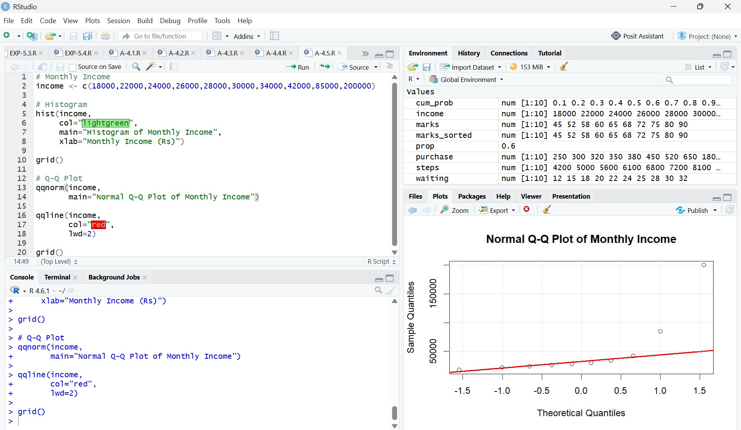

CODE:

# Monthly Income

income <- c(18000,22000,24000,26000,28000,30000,34000,42000,85000,200000)

# Histogram hist(income,
col="lightgreen",

main="Histogram of Monthly Income", xlab="Monthly Income (Rs)")

grid()

# Q-Q Plot qqnorm(income,
main="Normal Q-Q Plot of Monthly Income") qqline(income,
col="red", lwd=2)
grid()

Interpretation Histogram
- Most incomes fall between ₹18,000 and ₹42,000.
- Two very high incomes (₹85,000 and ₹200,000) create a long right tail.
- Therefore, the histogram is highly positively skewed.

Q-Q Plot

- Points deviate considerably from the straight reference line.
- The upper-right points lie far above the line due to the very high incomes.
- This indicates that the data is not normally distributed.

Conclusion
The monthly income data is highly positively skewed rather than normally distributed. The histogram shows a long right tail, and the Q-Q plot confirms this by displaying significant departures from the reference line.

